Date- 13th January 2026

PLACEMENT CELL
Report On- ON CAMPUS DRIVE A.Y. 2025-26

On 12th January 2026, a On Campus Ateion Pvt. Ltd. was organized by Pratibha College of Commerce and Computer Studies. Students of Pass out year of 2025-26 of TY B.Com, TY BBA, TY BBA(IB), TY BBA(CA), TY BSc(CS), TY BCA(Sci), TY BSc(Reg), TY BSc(CDS) TY BA, FY M.Com, FY MSc(CS), FY MSc(CA), FY MCA, SY M,Com, SY MSc(CS), SY MSc(CA), SY MCA participated in the On Campus Placement Drive organized by Pratibha College of Commerce and Computer Studies.

There was an introduction given about the Company type and the number of openings and other necessary details were given. The HR Conducted one-on-one Interview round for the interviews. Entire team of Placement Cell was present to make this event reach at success. HR’s were given the opportunity to discuss about various job roles which they wished to hire on the day of campus drive.

Total 2 students were selected from this On Campus Drive out of 110 Students registered in offline mode.

Dr. Harshita Vachhani Dr. Kshitija Gandhi
Head, Training & Placements I/C Principal

Output of the Event: -

Name of the Company: | Ateion Pvt. Ltd
Eligibility: | TY B.Com, TY BBA, TY BBA(IB), TY BBA(CA), TY BSc(CS), TY BCA(Sci), TY BSc(Reg), TY BSc(CDS) TY BA, FY M,Com, FY MSc(CS), FY MSc(CA), FY MCA, SY M,Com, SY MSc(CS), SY MSc(CA), SY MCA , MBA Of pass out year 2024-25 , 2025-26
Number of the students registered | 65 (Online) & 23 (Offline)
Finally Placed Students: | 16

Name of the Students | Gender | Email ID | Phone Number
Anjali Ajit Jha | Female | jhaa11555@gmail.com | 9890135993
Neha Rakesh Tripathi | Female | nehatripathi734@gmail.com | 9119589439
Puja Sham Mali | Female | pujamali314@gmail.com | 9075591829
Mukesh Shinde | Male | shindemukesh707@gmail.com | 9225516427
Siddhi Salunke | Female | siddhisalunke76669@gmail.com | 7666998091
Abhay Sharma | Male | abhayanilsharma@gmail.com | 9980451005
Tanaya Deepak Wani | Female | tanayawani13@gmail.com | 7499439464
Gauri Bhore | Female | gauribhore86@gmail.com | 9763105323
Pranay Pol | Male | pranaypol10@gmail.com | 9607732500
Rushikesh Nikam | Male | rushikesh.nikam.aws@gmail.com | 7498573735
Pragati Ajit Pol | Female | pragatipol32@gmail.com | 9325694847
Ritesh Badhe | Male | riteshbadhe65@gmail.com | 8805060013
Rishi Jadhav | Male | rrj19705@gmail.com | 8308499616
Olive Varughese | Female | oliveviju@gmail.com | 7559102601
Manasi Wadekar | Female | wadekarmanasi8@gmail.com | 8261016227
Shruti Pawar | Female | shrutip5070@gmail.com | 9309065138

NOTICE: -

HR FEEDBACK:
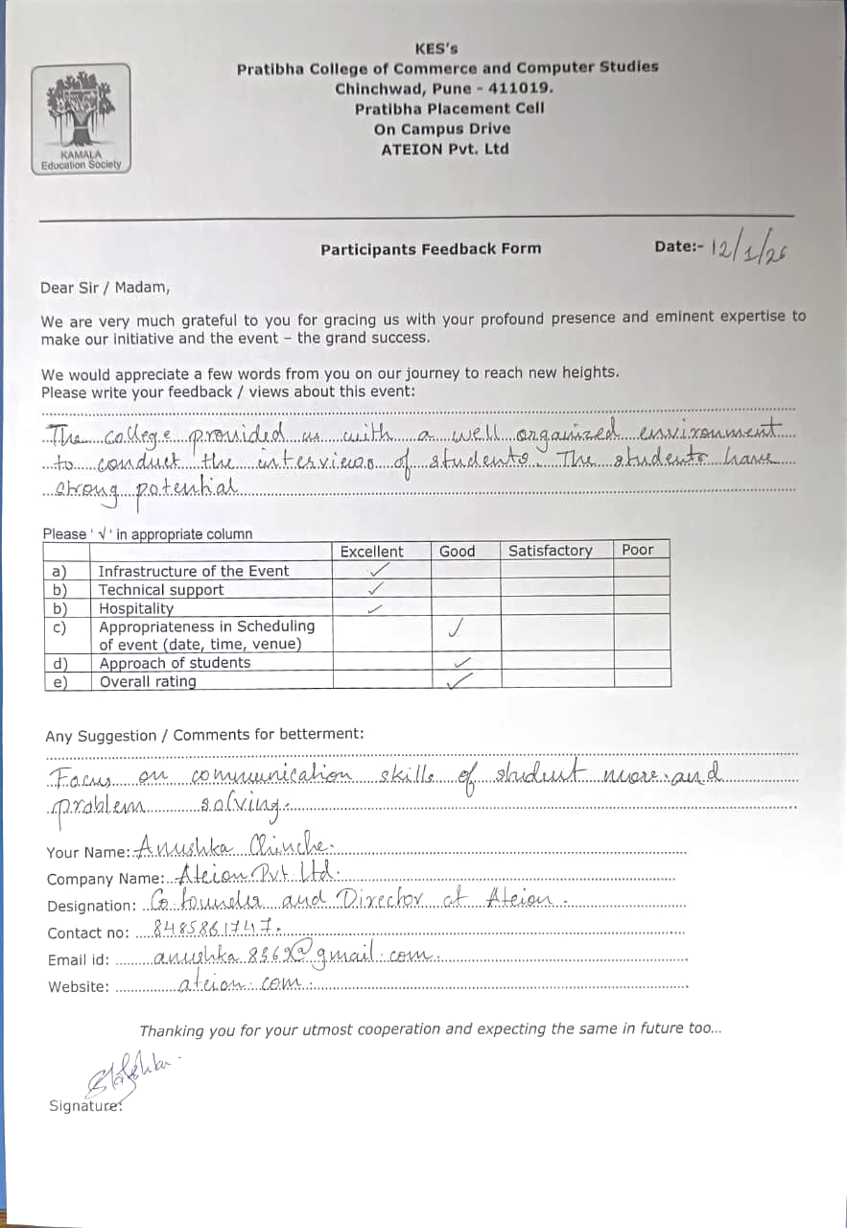

STUDENTS FEEDBACK: -

Glimpses: Registration

Interview: HR Round

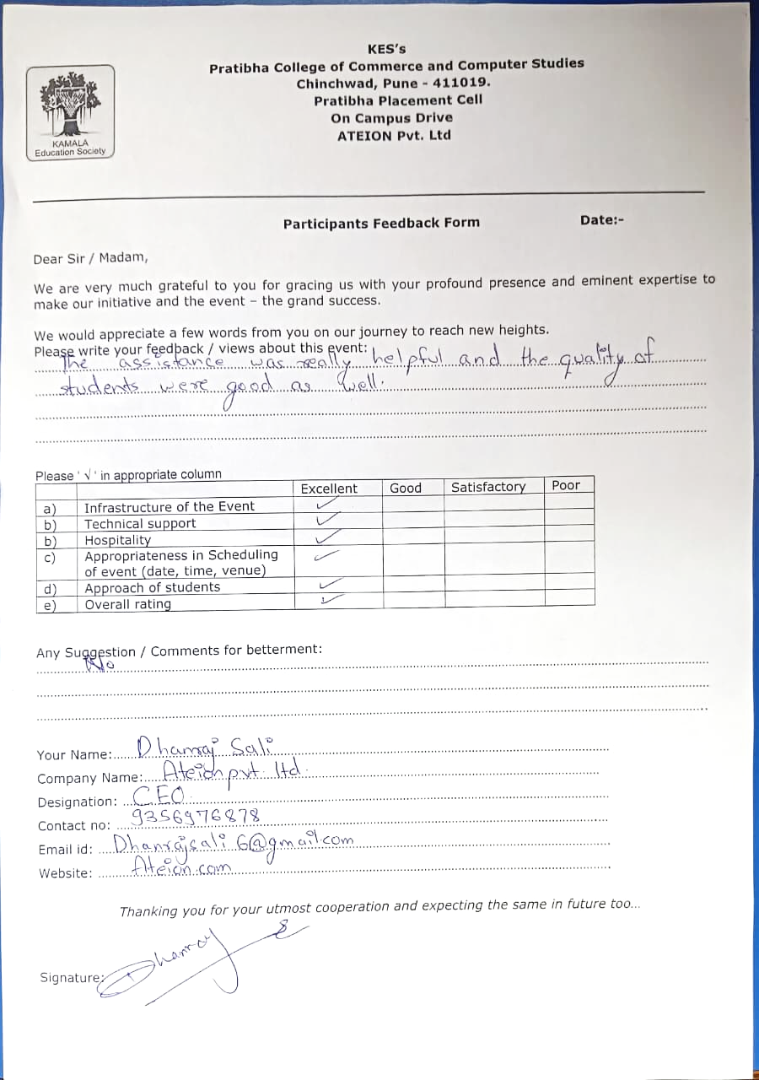

REGISTRATION:-
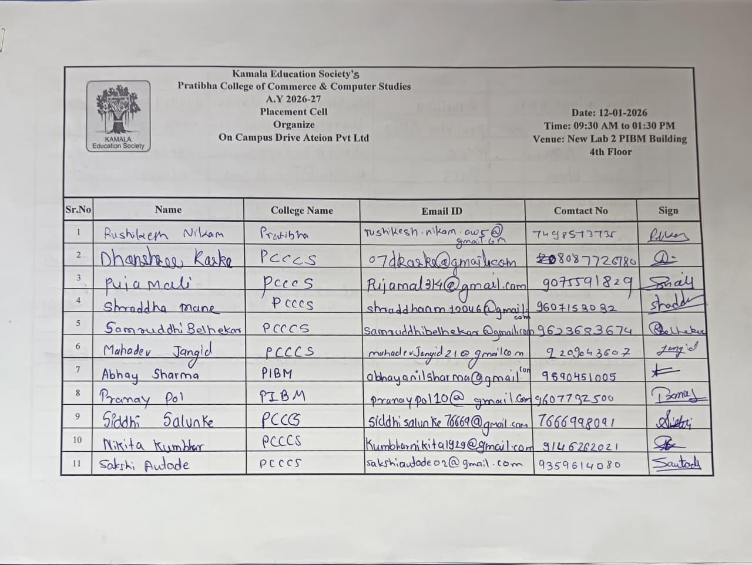
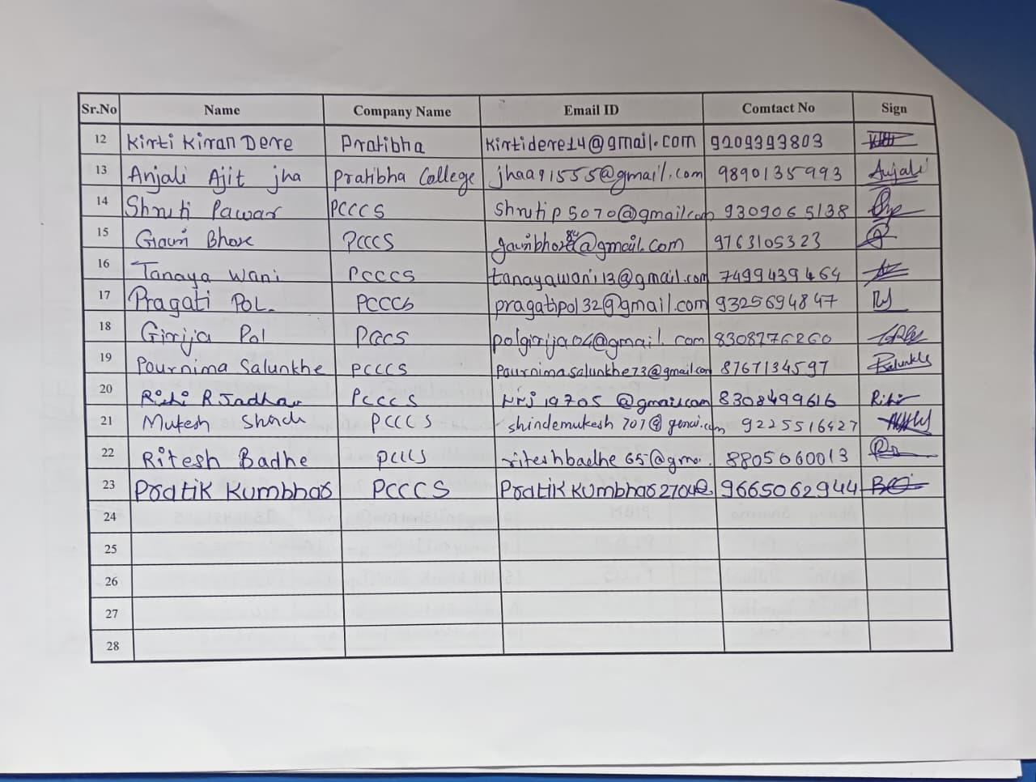
STUDENT FEADBACK

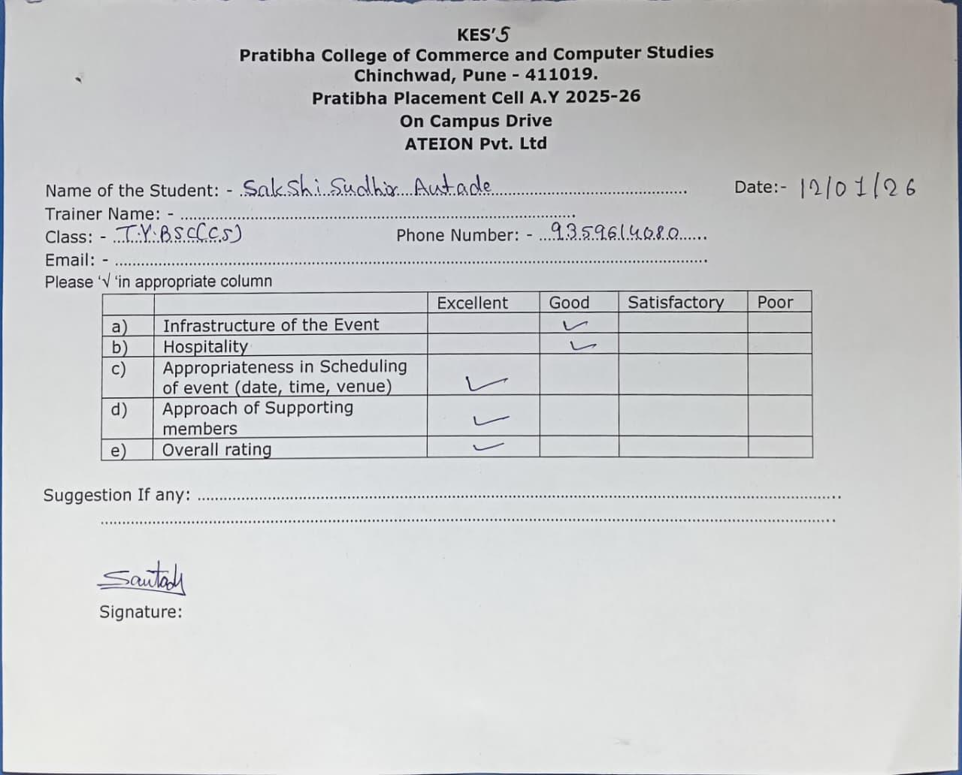
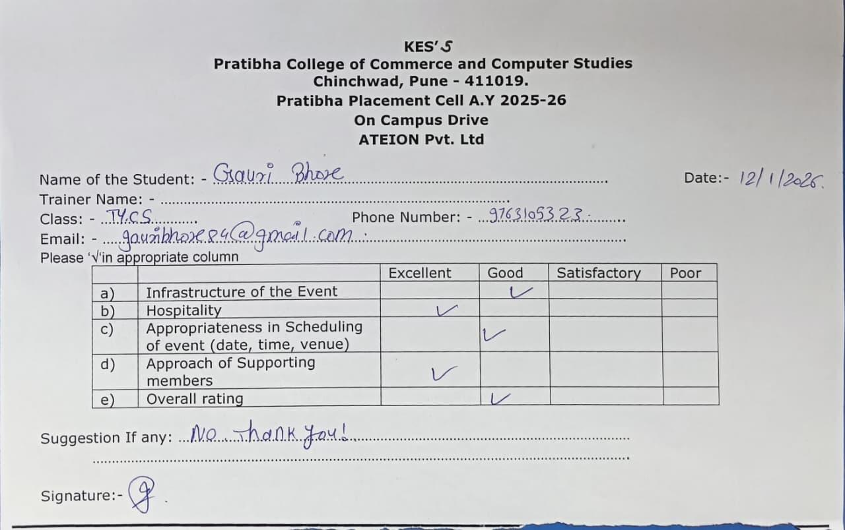
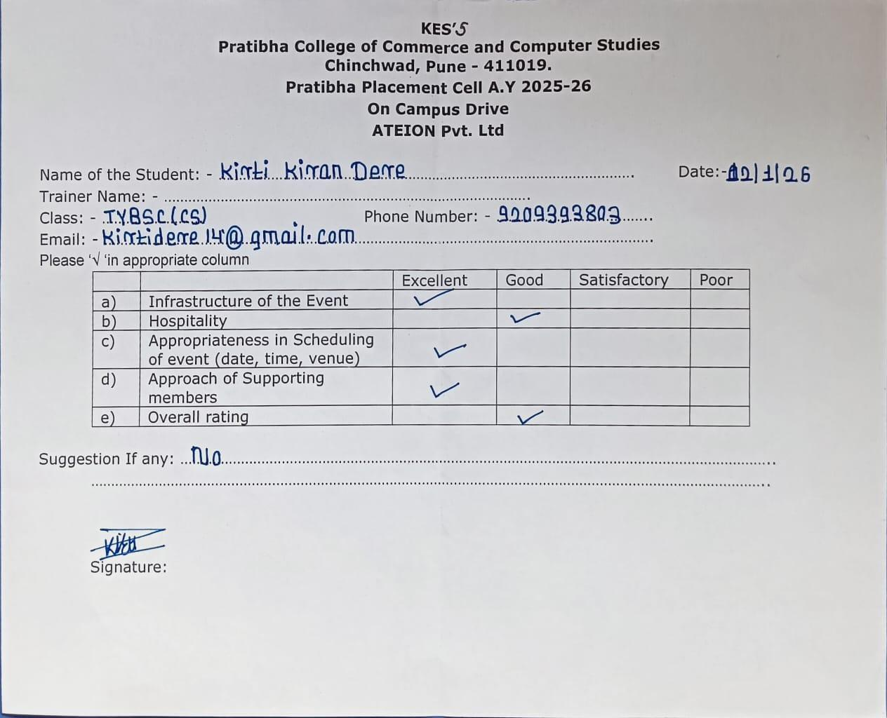
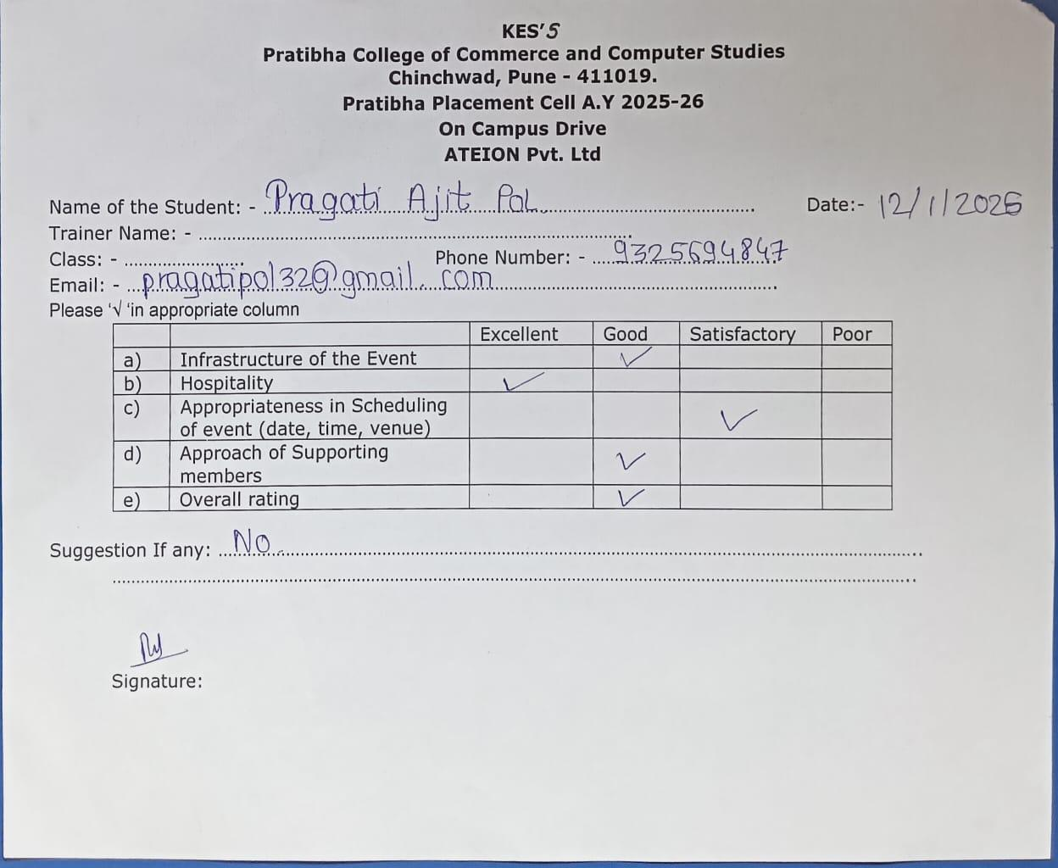
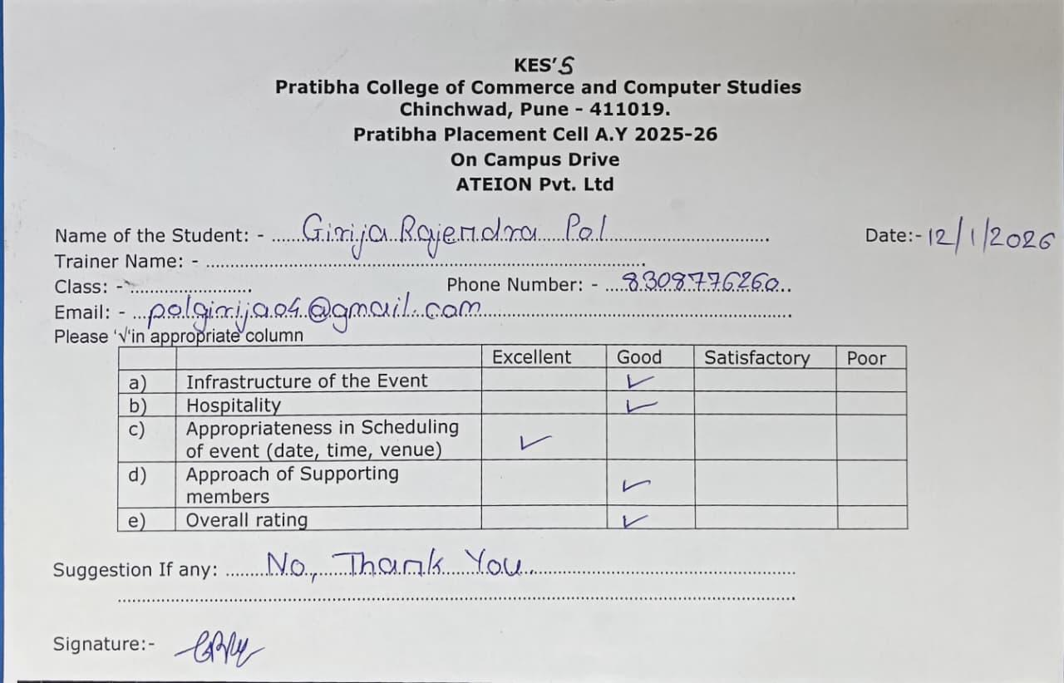
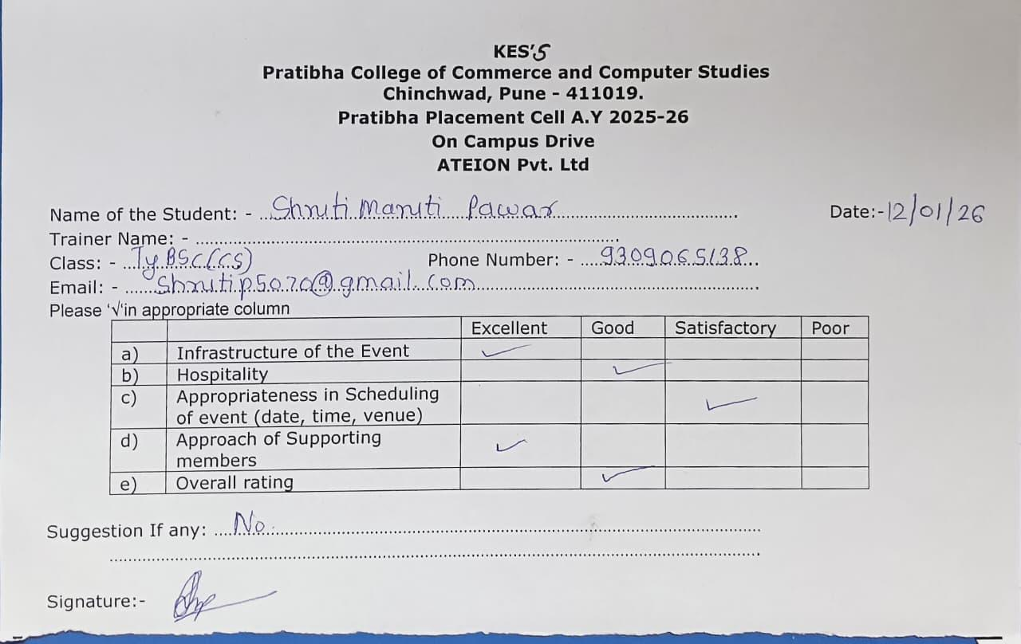
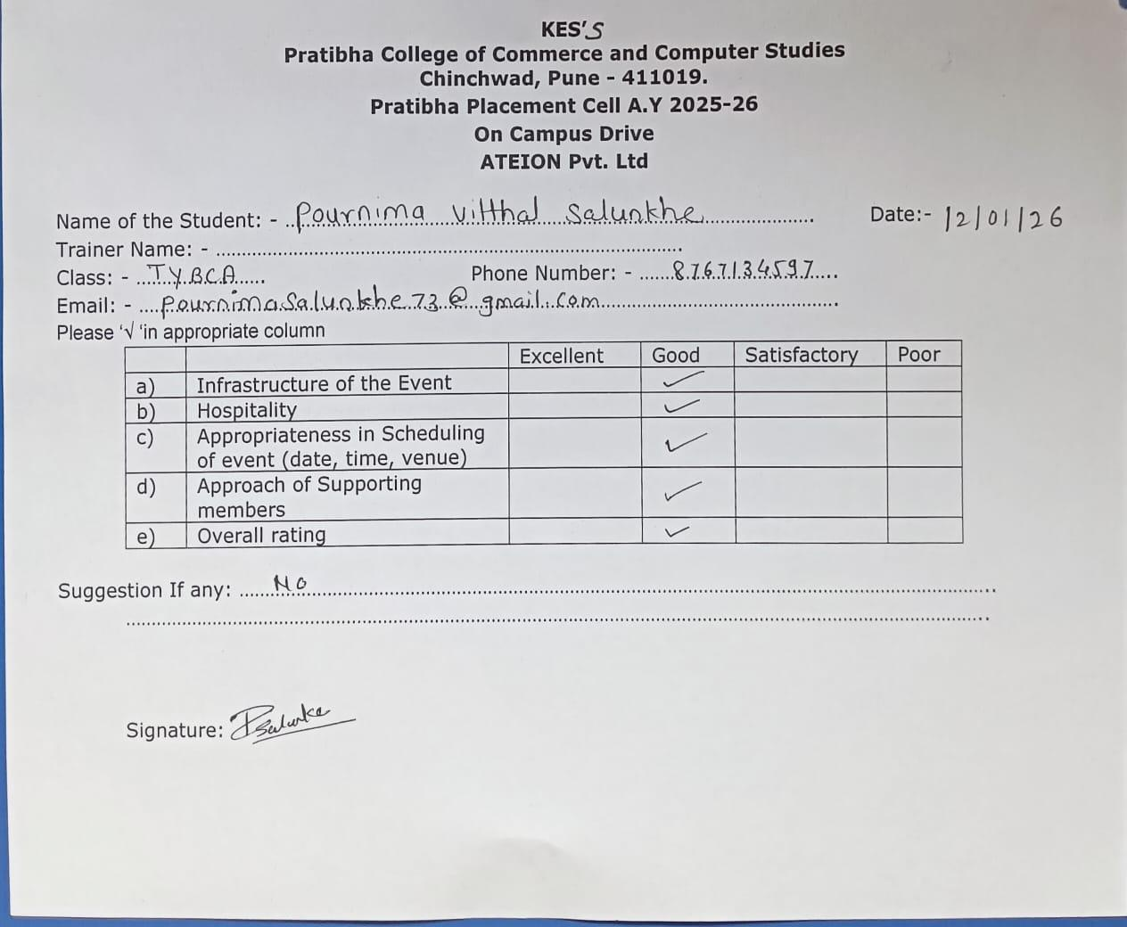

Glimpses:-
